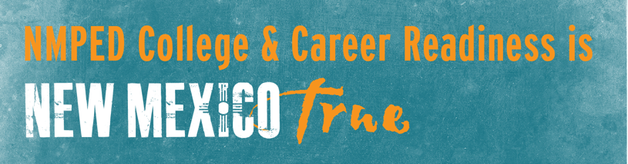

Building the Next Generation
of Career and Technical Education
Outcomes – March 2 Region I Consortia Meeting
Vision Statement: (I made a few revisions to what we discussed in the room based on some feedback. If you have anything you’d like to tweak, please just let me know!)
Career and Technical Education in Region I generates well-informed, well-rounded talent. It brings together all of the partners, assets, and investments in the region to be aligned and responsive to the needs of industry and economic development. CTE provides both career exposure and training to create the best possible opportunities and outcomes for students and families.

Target Industries for Investment:
- Agriculture, to include:
  - Manufacturing
  - Welding
  - Business management
  - Trades
  - Logistics
- Manufacturing
- Technology to support:
  - Needs of the Defense Industry
  - Opportunities in the Gig Economy
  - Increased opportunities for SoloWork
  - Application of skill sets that cut across all industries in the region

Top Programs of Study to Pursue Include:
- Information Technology (19 votes)
- Manufacturing (18 votes)
- Agriculture (12 votes)
- Transportation and Logistics (4 votes)

ALL of the educational partners will be participating in this collective effort! Additional partners will include:
- The United Way and its workforce-focused partnership will support for the development of the Information Technology and Manufacturing-focused goals to maximize the economic benefits to the region of these programs.
- Clovis and Portales EDC’s will stay engaged in leveraging employers in the region to expand work-based learning opportunities for students
- Tiffany Bretz with Southwest Cheese will participate in the consortia’s efforts to advance its goals
- Michael Stein will work with Juvenile services to engage at-risk youth in these career exploration and training programs

The Eastern Workforce Board will work in partnership with the Region on their Sector Strategies, which included alignment on Agriculture, but also cover the two other industries brought up by the group:
- Allied Health
- Education

Opportunities to Pursue Moving Forward:
- Parent education surfaced as a big priority to address. Solutions include:
  - Integrating parents into career exploration activities, including student presentations on their own career exploration efforts
  - Elevate awareness for parents of the outcomes of the PSAT that outline potential careers for students
  - Family engagement specialists and the Youth Success program may be another way to reach parents
- Career exploration needs to start early. Perkins V supports career exploration for middle school students, which should be explored by the consortia.

NOTES FROM THE DISCUSSION:

Characteristics of the Workforce Talent of Region I:
- Able to Train
- Soft skilled (3)
- Critical Thinking (2)
- Enthusiasm
- Attitude
- Employable
- Reliability

Characteristics of our CTE program to build the talent we need:
- Talent will be:
  - Well rounded
  - Have ethics
  - Good communication skills
  - Dependable
- System will:
  - Create opportunities that students/graduates can attain
  - Responsive, pro-active, and flexible to the needs of the region
  - Maximizes collaboration
  - Provides exposure to rewarding local careers and industries
  - Delivers training virtually

